Standing Wave Lab 6
Student’s Name
Institutional Affiliation

Abstract
If a string between two fixed supports pulled tightly and sharply plucked at one end, a pulse will travel from one end on the string to the other. When the string is plucked, it gains energy which travels through the medium as a transverse pulse. The particles in transverse wave vibrate perpendicular to the direction of wave travel. The speed of the particles the string is a function of linear density and the tension in the string
Aim: to study the characteristic of standing wave

Standing Wave Lab 6
Introduction
Waves are periodic disturbances propagating in space and time. The following definitions are important in the learning and studying waves.
Examples of wave in real live situation includes radio waves by means of electromagnetic waves, human breathing, when water is disturbed among others.
- The period T is the time taken for one oscillation
- The frequency f =1/T is the number of oscillation per second, in Hz
- Wavelength ʎ is the distance between two points in a wave front
- Amplitude A is the maximum displacement of the wave
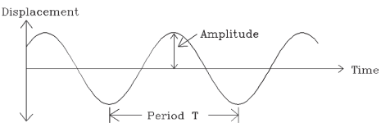
Theory
If a string between two fixed supports pulled tightly and sharply plucked at one end, a pulse will travel from one end on the string to the other. When the string is plucked, it gains energy which travels through the medium as a transverse pulse. The particles in transverse wave vibrate perpendicular to the direction of wave travel. The speed of the particles the string is a function of linear density and the tension in the string.
V=$\sqrt[ 2]{T/µ}$
Where v is the speed of the poetical
T is the tension in the string
µ is the linear density of the string
The purse is reflected from where it is tied to the support. When the reflection occurs from low density medium to one of the higher density, the reflection invers the pulse and it travel back down the string in reverse direction. Applying the Newton’s third law of action and reaction, when the pulse heat the wall it will exerts an upward pull in the pulse has positive amplitude. The wall then exerts a downward pull on the string and the reflected purse is inverted, giving it negative amplitude.
If a series of pulses is put on the string by an oscillator, there will be a train of positive pulses travelling to the right and a train travelling to the left. When the two will meet, they will interfere destructively, cancelling each other out momentarily and then reappear again.
Standing waves on a string are as results of travelling waves interfering bot destructive and constructive. The nodes are due to destruction while antinodes are as results of constructive interference (Levine & Curry, 2016). When a standing wave appears, the nodes ad antinodes are fixed in place. When the conditions of the tension in the string, the linear density and the frequency of oscillations are just right, standing wave appear.
A wave has both frequency and wavelength which are related to the velocity
ʎf = v
f frequency
ʎ wavelength
v velocity
The wavelength of standing waves is fixed by the length of the string. When both ends are fixed, there must have nodes at each end of the spring. Standing waves are sinusoidal
Hence the allowed number of waves on the string will be an integral number of half wavelengths.
It follows that.
V=$\sqrt[ 2]{T/µ}$ =ʎf
When a graph of inverse of the frequency on the x-axis, against the wavelength on the y-axis is plotted, the slope of the line is $\sqrt[ 2]{T/µ}$
When the tension T is known, the linear can be calculated
Procedure
The project is done by use of online simulation which represents wave on a string. The simulation allows the in amplitudes, frequency set up the string with fixed end, loose, and no end.
Part A: Fixed at both ends
- Find the lowest frequency that will establish a standing wave. This is the fundamental frequency.
- Determine the number of nodes, antinodes, and wavelengths for this frequency. Create a data table with 5 columns (frequency, 1/ frequency, nodes, antinodes, and wavelengths), and enter this data. Be careful with wavelengths; you should figure out how many wavelengths there are in the length of the string. Draw the standing wave and label the Nodes with “N” and Antinodes with “A”.
- Increase the frequency until you find the next one that will establish a standing wave. Find the values listed in Step 2 for this standing wave, enter them into the data table, and draw and label the wave.
- Continue increasing the frequency and entering the data for additional standing waves
Table of data and analysis
Frequency (Hz) | 1/frequency(1/Hz) | Wavelengths (m) | nodes | Antinodes
0.5 | 2 | 0.152 | 2 | 1
1 | 1 | 0.076 | 3 | 2
1.25 | 0.8 | 0.051 | 4 | 3
1.5 | 0.667 | 0.038 | 5 | 4
Table 1: Data for part A
Diagrams
- Two nodes and I antinodes
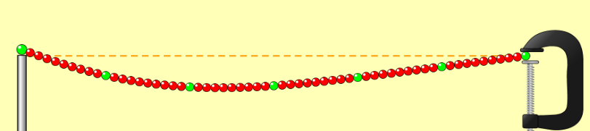
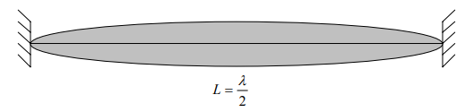
- Three nodes and two antinodes
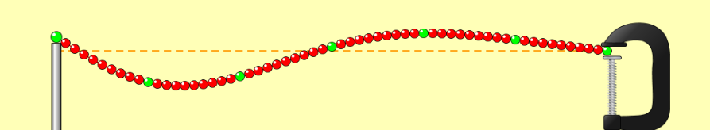
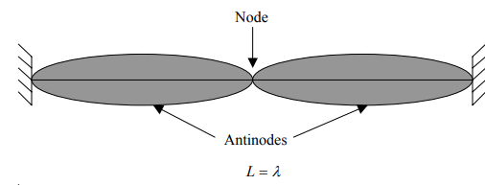
- Four nodes and three antinodes
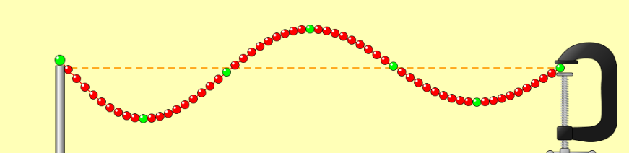
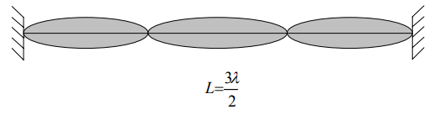
- Five nodes and four antinodes
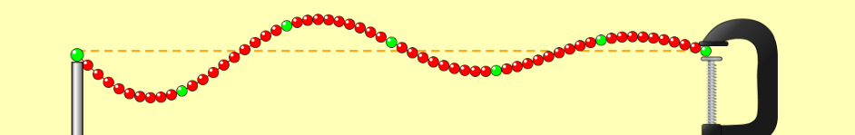
Graph of the inverse of the frequency on the x-axis, against the wavelength on the y-axis
Figure 1:Inverse of the frequency against the wavelength

Slope =$\sqrt[ 2]{T/µ}$
Slope = (0.152 – 0.076)/(2-1)
S= 0.76
Therefore 0.5776 = 10/µ
Hence µ = 10/0.5776
µ= 17.31
Calculation of linear density
Solution
Linear density of the string is equal to the mass divided by the length of the string
µ = M/L
M=T/g
M=10/10
M=1KG
µ = 1/0.076= 13.158

Speed of the transverse wave
V = T/µ
V =10/13.157
=0.87m/s
Conclusion
Calculated string density = 13.158
Theoretical value 17.3
The error in the calculated and theoretical value can be caused due to the parallax when collecting the data, since it is not possible to read the exact values. It is also not possible to see there the nodes start (Levine & Curry, 2016). The uncertainties in all other errors also caused the values to be different.
Part B: Free at both ends
- Find the lowest frequency that will establish a standing wave. This is the fundamental frequency.
- Determine the number of nodes, antinodes, and wavelengths for this frequency. Create a data table with 5 columns (frequency, 1/ frequency, nodes, antinodes, and wavelengths), and enter this data. Be careful with wavelengths; you should figure out how many wavelengths there are in the length of the string. Draw the standing wave and label the Nodes with “N” and Antinodes with “A”.
- Increase the frequency until you find the next one that will establish a standing wave. Find the values listed in Step 2 for this standing wave, enter them into the data table, and draw and label the wave.
- Continue increasing the frequency and entering the data for additional standing waves

Table of data
Frequency (Hz) | 1/frequency(1/Hz) | Wavelengths (m) | nodes | Antinodes
0.5 | 2 | ½ | 1 | 2
1 | 1 | 1 | 2 | 3
1.5 | 0.667 | 4-Jul | 3 | 4
2 | 0.5 | 4-Sep | 4 | 3
Table 2: Data for part B
Diagrams for no ends
- One node and two antinodes
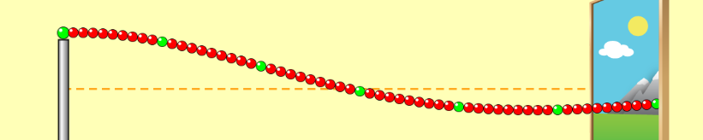
- Two nodes and three antinodes
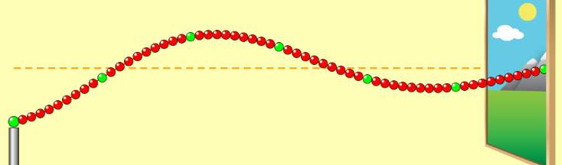
- Three nodes and four antinodes
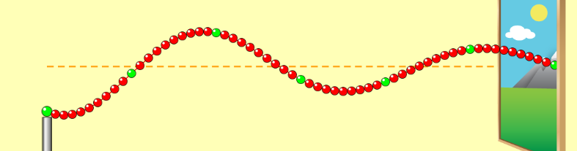
- Four nodes and five antinodes
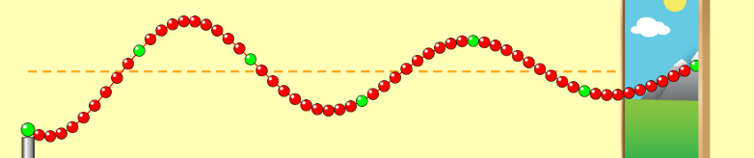
Part C: Free at one end
- Find the lowest frequency that will establish a standing wave. This is the fundamental frequency.
- Determine the number of nodes, antinodes, and wavelengths for this frequency. Create a data table with 5 columns (frequency, 1/ frequency, nodes, antinodes, and wavelengths), and enter this data. Be careful with wavelengths; you should figure out how many wavelengths there are in the length of the string (Levine & Curry, 2016). Draw the standing wave and label the Nodes with “N” and Antinodes with “A”.
- Increase the frequency until you find the next one that will establish a standing wave. Find the values listed in Step 2 for this standing wave, enter them into the data table, and draw and label the wave.
- Continue increasing the frequency and entering the data for additional standing waves

Frequency (Hz) | 1/frequency(1/Hz) | Wavelengths (m) | nodes | Antinodes
0.2 | 5 | ¼ | 1 | 1
0.4 | 2.5 | ¾ | 2 | 2
1 | 1 | 5-Apr | 3 | 3
1.5 | 0.667 | 4-Jul | 4 | 4
Table 3: Data for part C
Diagrams
- One node and one antinode
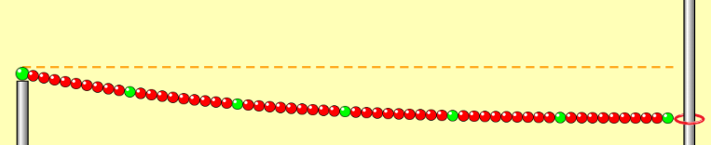
- Two nodes and two antinodes
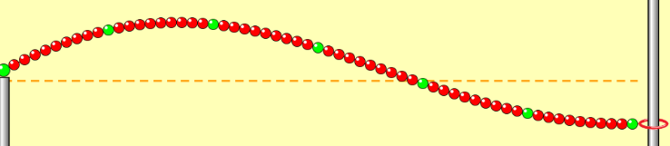
- Three nodes and three anodes
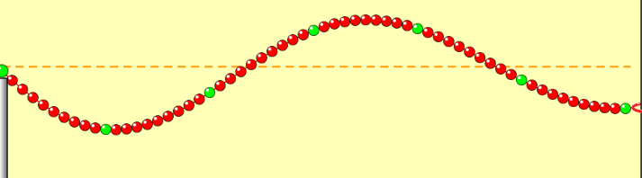
- Four anodes and four antinodes
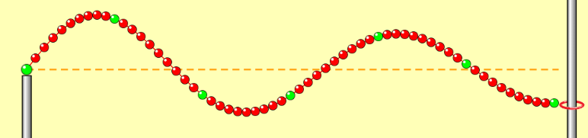
Conclusion
Compare and discus the result in part A, B, and C.
- In part A, the number nodes are not equal to the number of antinodes. The number of nodes exceeds the number of antinodes by 1
- In part B, the antinodes exceeds the nodes by 1 as indicated in the table of values in part B
- In part C, the number of antinodes is equal to the nodes.

Reference
Levine, Z. H., & Curry, J. J. (2016). OptSortSph: Optical Sorting in a Standing Wave Field Calculated with Effective Velocities and Diffusion Constants. Journal of Research of the National Institute of Standards and Technology, 121(Journal of Research of the National Institute of Standards and Technology).

